Surprise Test 1 Solution

https://www.facebook.com/events/140824550065774/140836593397903

Set 1

https://www.youtube.com/watch?v=Ua_WwC2Izqo&feature=youtu.be

Set 2

https://www.youtube.com/watch?v=mxeXRbt1_0Y&feature=youtu.be

set 3

https://www.youtube.com/watch?v=4IVTnRgL054&feature=youtu.be

set 4

https://www.youtube.com/watch?v=rREp1TcUUB8&feature=youtu.be

Done for today.  
Solve a Question not from the surprise test.  
Solution: tomorrow.

Divya applied to colleges in four different countries – A, B, C and D – to pursue her post-graduation. Among these colleges, she was accepted into a few colleges, while she was rejected from the remaining. The first pie chart below gives the percentage breakup of the number of colleges that she applied to, by the country in which the college is present. The second pie chart gives the breakup of the number of colleges, by country, into which she was accepted.

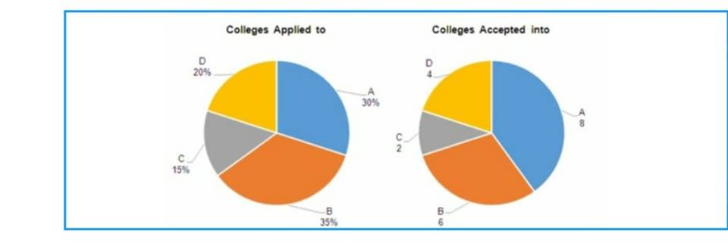

What is the minimum number of colleges that Divya could have applied to (considering the percentages   
breakup in the first pie chart to be exact)?   
a) 20   
b) 14   
c) 27

If Divya was rejected by exactly two-thirds of the colleges that she applied to in C, how many colleges would   
she have applied to in all?   
a) 20   
b) 40   
c) 60   
d) 80

If Divya was rejected by a total of 40 colleges, how many colleges in D rejected her?  
  
a) 4   
b) 5   
c) 6  
D)8

If Divya was rejected by 12 colleges in D, what percentage of colleges that she applied to in C would have   
rejected her?   
a) 83.33%   
b) 16.67%   
c) 66.67%   
d) 33.33%